[ZANG] - [Chuanjie]

Student ID: 699382953

[chuanjiezang@gmail.com](mailto:chuanjiezang@gmail.com)

Question 1

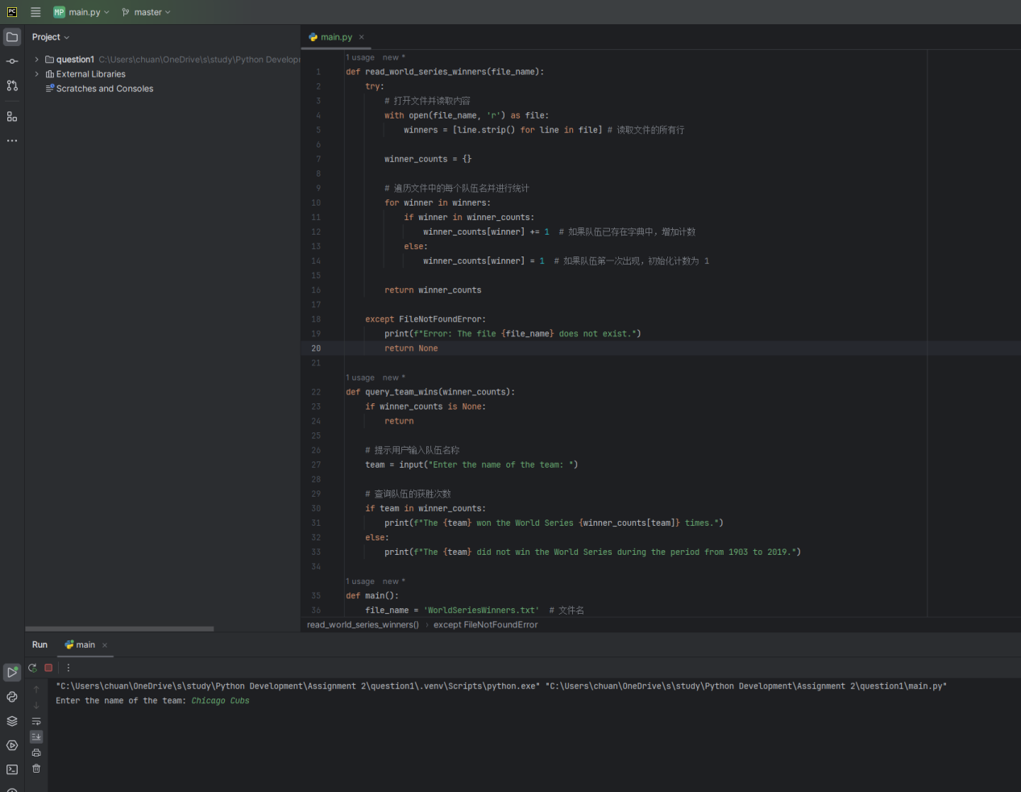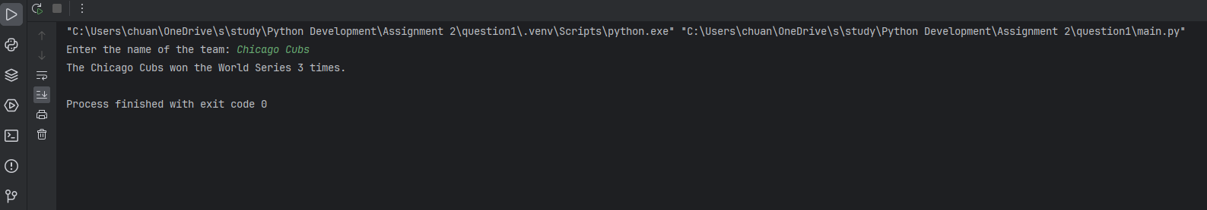

Question 2

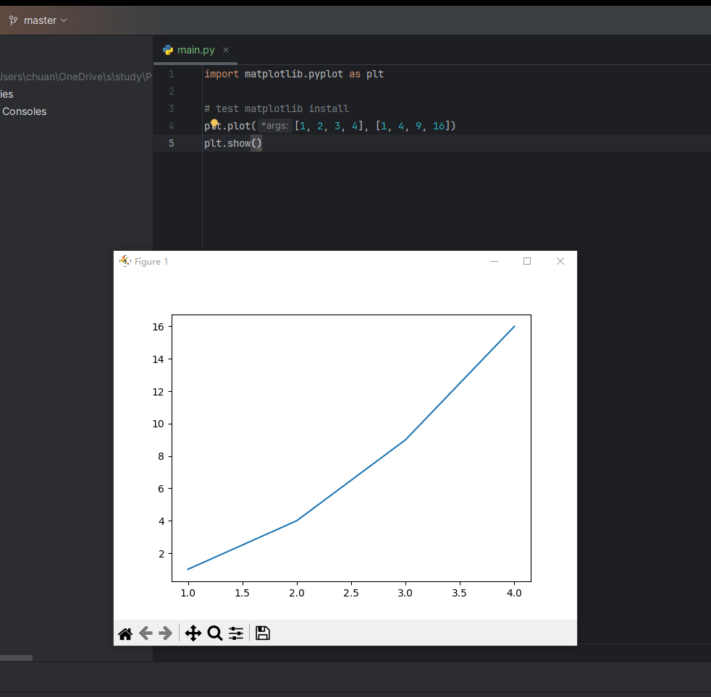

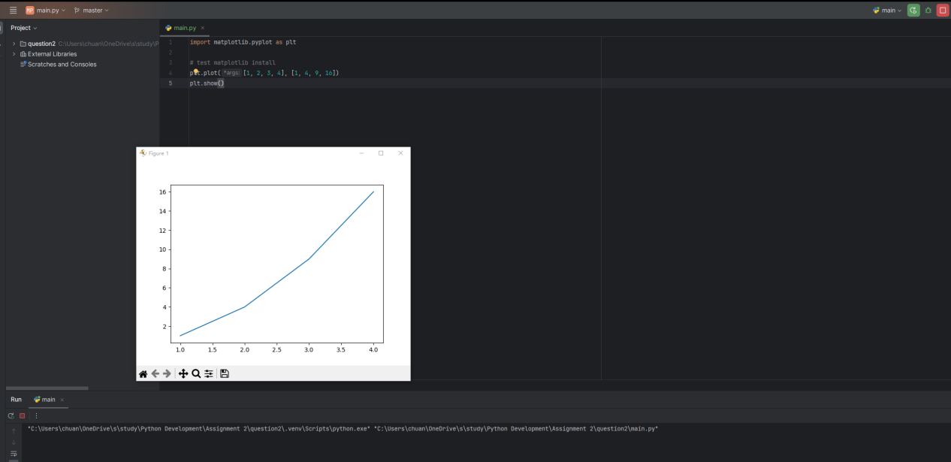

Question 3

